# CS 255 Business Requirements Document

Complete this template by replacing the bracketed text with the relevant information.

This template lays out all the different sections that you need to complete for Project One. Each section has guiding questions to prompt your thinking. These questions are meant to guide your initial responses to each area. You are encouraged to go beyond these questions using what you have learned in your readings. You will need to continually reference the interview transcript as you work to make sure that you are addressing your client’s needs. There is no required length for the final document. Instead, the goal is to complete each section based on your client’s needs.

**Tip:** You should respond in a bulleted list for each section. This will make your thoughts easier to reference when you move into the design phase for Project Two. One starter bullet has been provided for you in each section, but you will need to add more.

## System Components and Design

### Purpose

*What is the purpose of this project? Who is the client and what do they want their system to be able to do?*

* DriverPass provides driver training to prepare their customers to successfully pass their driver test at the DMV by providing on-the-road training along with optional personal training, online class materials, and online practice tests. DriverPass wants a cloud-based web application that can set and track their client’s driver training progress and provide online class material and practice tests.

### System Background

*What does DriverPass want the system to do? What is the problem they want to fix? What are the different components needed for this system?*

* In order to meet the need for better driver training and help people successfully pass their driving tests at the DMV, DriverPass wants their system to be able to schedule on-the-road training appointments, provide online class materials, provide online practice tests, and keep up to date with requirements from the DMV. This application needs to be accessible as online without requiring any software installation.

### Objectives and Goals

*What should this system be able to do when it is completed? What measurable tasks need to be included in the system design to achieve this?*

* Input customer information
* Display and capture package selection
* Allow package options to be removed by owner
* Allow users passwords to be reset by IT
* Schedule/Change/Cancel reservations for on-the-road training sessions
* Allow trainers to log and record notes of training sessions
* Track/Log all activity by user, date, and data
* Display customer progress
* Alert that DMV updates are available
* Run off the web preferably cloud.
* No local backup or security burden.
* Allow data to be downloaded to authorized users
* Implement Roles and Rights based security access

## Requirements

### Nonfunctional Requirements

*In this section, you will detail the different nonfunctional requirements for the DriverPass system. You will need to think about the different things that the system needs to function properly.*

#### Performance Requirements

*What environments (web-based, application, etc.) does this system need to run in? How fast should the system run? How often should the system be updated?*

* Web-Based (Cloud Application)
* System should be responsive to user input with minimal delay
* New data and data changes should occur real-time
* All transactions are logged
  + User information, add/modify/delete, changes
  + Appointments, add/modify/delete, changes
  + User log in activities including username retrieval and password reset requests

#### Platform Constraints

*What platforms (Windows, Unix, etc.) should the system run on? Does the back end require any tools, such as a database, to support this application?*

* Server should run on Linux to minimize cost and downtime due to OS upgrades
* Cloud database server should be used to store application/user information
* Security and Authentication services should be provided via cloud services
* Cloud based data retention plan should be implemented completely via cloud services

#### Accuracy and Precision

*How will you distinguish between different users?* *Is the input case-sensitive? When should the system inform the admin of a problem?*

* A unique user identification number will be assigned to each user
* Users will use a username or email address to login to system
* Log in ids will be case-insensitive
* Passwords are case-sensitive
* Passwords must include upper-case, lower-case, and special characters
* Company users will be able to look up customers customer attributes
  + Name
  + Address
  + Pickup Location
  + Etc…
* Admin will be informed of any locked accounts due to failed log-in attempts.

#### Adaptability

*Can you make changes to the user (add/remove/modify) without changing code? How will the system adapt to platform updates? What type of access does the IT admin need?*

* All user information is updateable except user identification number
* Services offered can be enabled/disabled by authorized user role
* Specific data can be restricted on a user role basis such as:
  + Driver notes
  + Internal account comments
  + Etc…

#### Security

*What is required for the user to log in? How can you secure the connection or the data exchange between the client and the server? What should happen to the account if there is a “brute force” hacking attempt? What happens if the user forgets their password?*

* System will lock user’s account after three failed-attempts to log in
* Two factor authentication should be implemented
* System will provide forgot username link to inform user of their username
* System will provide forgot password link to reset user’s password if account is not locked
* Only admin can reset locked user accounts
* Admin can only reset passwords to one time use passwords requiring change on first log-in

### Functional Requirements

*Using the information from the scenario, think about the different functions the system needs to provide. Each of your bullets should start with “The system shall . . .” For example, one functional requirement might be, “The system shall validate user credentials when logging in.”*

* The system shall validate user credentials using two-factor authentication when logging in.
* The system shall provide accessibility from desktops, tablets, and mobile phones with internet connections and java compatibility.
* The system shall provide reports for download on a user-role basis.
* The system shall allow current product packages to be enabled or disabled on a user-role basis.
* The system shall allow customer to select an available product package.
* The system shall allow customer or authorized user-role to schedule an available driver session.
* The system shall allow customer to reschedule driving sessions with-in time period specified on a user-role basis.
* The system shall allow customer, and authorized user-role, to modify all customer information except user identification.
* The system shall allow authorized user-role, such as drivers, to log and comment on customer’s training progress.
* The system shall record user’s online test progress.

### User Interface

*What are the needs of the interface? Who are the different users for this interface? What will each user need to be able to do through the interface? How will the user interact with the interface (mobile, browser, etc.)?*

* Customer users will need to be able to provide all the following activities from a personal computer, tablet, or mobile phone having internet access and supporting Java:
  + Create new account
  + Request user login id
  + Request user password reset
  + Edit customer information
  + Select package choice
  + Take online tests
  + View their progress/status
  + Schedule driver session
  + Reschedule/Cancel driver session
  + Send email/message to DrivePass “customer service”
  + Send email/message to Driver
* Secretary users need to be able to:
  + Provide all Customer activities on a personal computer.
  + Update all schedules.
  + Print schedules.
  + Print reports.
* Drivers:
  + Need to update their schedule.
  + Enter/record student training log.
  + Edit driver information.
* Admin users need to be able to:
  + Create SQL reports.
  + Create users.
  + Designate user roles
  + Unlock accounts.
  + Clear/Reset password to one-time passwords that must be changed on first log in.
* Owner user needs to be able to:
  + Enable or disable product packages.
  + Create/Update/Delete Drivers.
  + Create/Update/Delete Schedules.
  + Download reports from database.

### Assumptions

*What things were not specifically addressed in your design above? What assumptions are you making in your design about the users or the technology they have?*

* Data access to internet is required for application access.
* Platform specific compatible web-browser at or above compatible revision level required for application access.
* Platform specific Java runtime at or above specified level required for proper application functionality.
* User required to be able to respond to two-factor authentication.

### Limitations

*Any system you build will naturally have limitations. What limitations do you see in your system design? What limitations do you have as far as resources, time, budget, or technology?*

* Application speed limited by data connection speed to internet.
* User interfaces requiring testing on different platforms, i.e., desktop, tablet, or mobile, and on different screen sizes and geometry could increase development complexity, time requirement, and cost.
* Creating/Updating/Deleting product packages requires a developer level change.
* Report changes or additions may require a developer level change.
* Cloud services provider must be agreed upon with DriverPass.

### Gantt Chart

*Please include a screenshot of the GANTT chart that you created with Lucidchart. Be sure to check that it meets the plan described by the characters in the interview.*

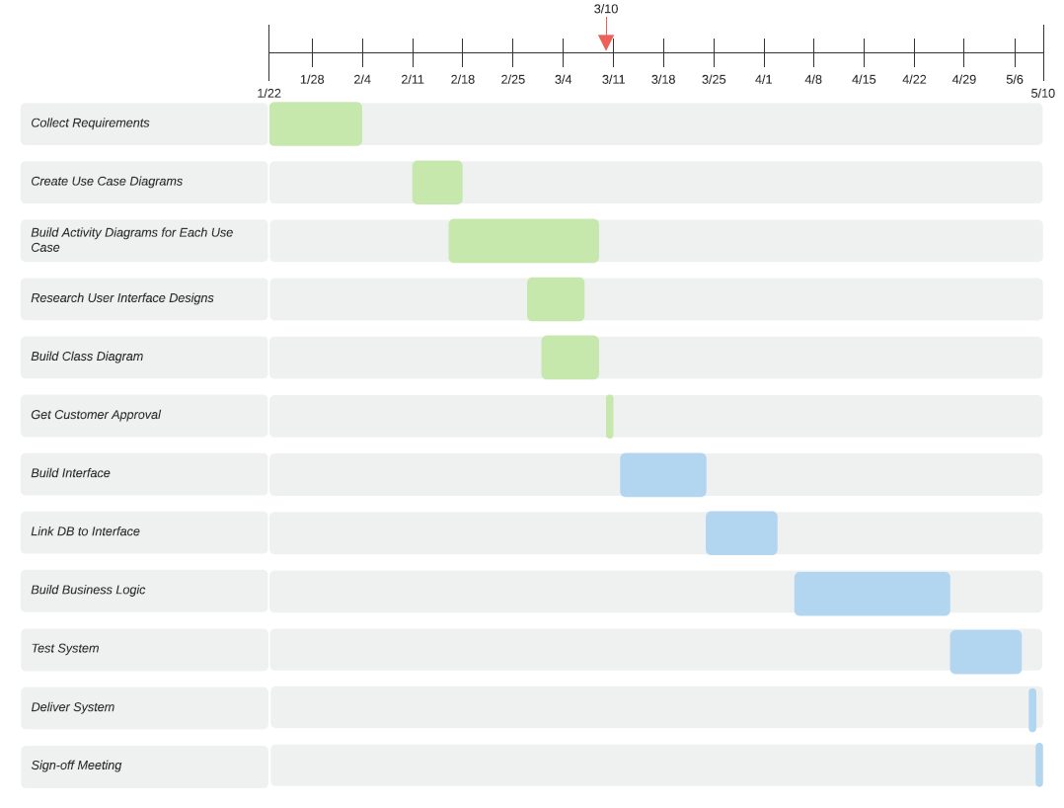

Figure 1 DriverPass Project Gantt Chart